TU Ilmenau
Microsoft Office and the Native Equation Editor
Some Initial Thoughts and Observations
Yuri Shardt

Table of Contents
Using Office’s Native Equation Editor 1
Section 1.1 : Numbering Equations 1
Section 1.2 : Referencing an Equation 2

List of Figures
Figure 1: Adding a Bookmark in Word 2019 2
Figure 2: Adding a Reference to a Bookmark in Word 2019 3

List of Tables
No table of figures entries found.

Using Office’s Native Equation Editor
Since Office 2016, it has now been possible to edit and manage equations using a native equation editor. This equation editor uses the Unicode-compliant math standard. This allows for the display of mathematical equations within text. However, it can be noted that, as with all things Microsoft with respect to matters scientific, there are many features that are missing or hard to implement. The following section will briefly describe how to implement the missing features so that the functionability is as close as possible to the desired behaviour.

: Numbering Equations
Although it is not obvious, it is possible to number equations within the equation itself. However, this must be done carefully if it is desired that the equations be updated automatically.
To enter a equation number within an equation, do the following:
- Enter your equation normally.
- At the end of the equation, place a <SPACE> followed by # followed by the formatted number, for example, (1).
- Press ENTER. This last step is very, very important. The number will now be right aligned.
To create an automatically updating equation number, inside of placing a static number as above, place any of the following fields (including the curly brackets):
- {SEQ Equation \* ARABIC} [as a copiable field: 1]: This will create a numbered list using standard Arabic numbers (1, 2, 3,…).
- {SEQ Ch \c }.{SEQ Equation \s 1 } [as a copiable field: 0.2]: This will create an equation reference of the form Chapter#.Equation#. For this to work, you will need to define in all of your chapter headings the following {SEQ Chapter \r 3 \h} [as a copiable field: ].
Note that in order for you to insert the field correctly, you must first insert a field using INSERT → Quick Part → Field and select SEQ. At this point you can enter the information above (excluding the curly brackets). Once you have created the field once, you can then just copy the field and paste it as necessary.
To update the fields, CTRL + A and then F9. To see all the fields in a document, press ALT + F9.

: Referencing an Equation
Unfortunately, for reasons that remain unknown, the Equation caption cannot be used to reference an equation created as above. In order to reference any equation, you need to create a bookmark.
To create a bookmark, highlight that part of the equation that you want to appear later. Goto INSERT → Bookmark. In the window that appears add a name for the bookmark (no spaces are permitted). I would recommend using the simple Equation_#. The steps are shown in Figure 1.
Then we you need to reference the equation, put the cursor, where you wish to insert the reference. Go to INSERT → Cross-referece. In the window that appears, select bookmark and select which bookmark you wish to reference. The link will then be made. Any changes in the numbering will be reflected in the link after updating the document. The steps are shown in Figure 2.
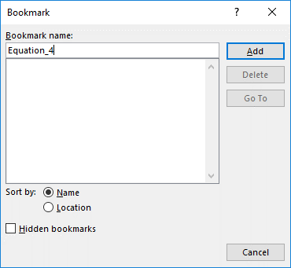
Figure 1: Adding a Bookmark in Word 2019
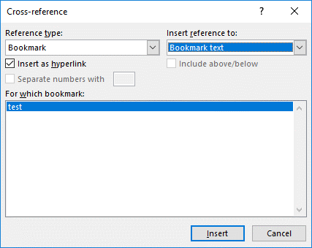
Figure 2: Adding a Reference to a Bookmark in Word 2019

